Lab 03 Encapsulation and Access Modifiers

Exercise 1
Question: Student with private name and marks 0–100; reject invalid marks in setter.
Java source code:
class ValidatedStudent {
private String name;
private int marks;

ValidatedStudent(String name, int marks) {
this.name = name;
setMarks(marks);
}
// The setter validates the marks before assigning them.
void setMarks(int marks) {
if (marks < 0 || marks > 100) {
throw new IllegalArgumentException("Marks must be 0 to 100");
}
this.marks = marks;
}

int getMarks() {
return marks;
}

String getName() {
return name;
}
}

public class Exercise1Student {
public static void main(String[] args) {
ValidatedStudent student = new ValidatedStudent("Leslie Sarai", 86);
System.out.println(student.getName() + ": " + student.getMarks());

try {
student.setMarks(120);
} catch (IllegalArgumentException e) {
// Invalid marks leave the previous value unchanged.
System.out.println(e.getMessage());
}
}
}

Expected output (sample):
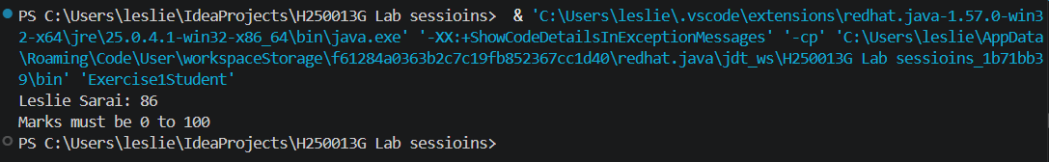Explanation: Private fields protect the data. setMarks validates values before updating marks.

Exercise 2
Question: Add getGrade() returning A, B, C or F without storing grade.
Java source code:
class GradeStudent {
private int marks;

GradeStudent(int marks) {
this.marks = marks;
}
// The method checks the highest grade threshold first.
String getGrade() {
if (marks >= 80) return "A";
if (marks >= 70) return "B";
if (marks >= 50) return "C";
return "F";
}
}

public class Exercise2StudentGrade {
public static void main(String[] args) {
// Check the highest grade threshold first.
System.out.println("Grade: " + new GradeStudent(86).getGrade());
}
}

Expected output (sample):
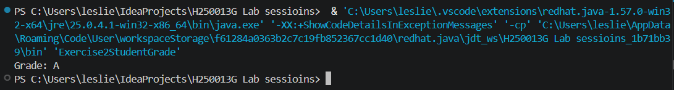Explanation: getGrade calculates the grade when called. It does not store a second value that could become out of sync.

Exercise 3
Question: Add transaction history to BankAccount and return an unmodifiable copy.
Java source code:
import java.util.*;

class BankAccount {
private double balance;
private final List<String> history = new ArrayList<>();

BankAccount(double opening) {
balance = opening;
history.add("Opened: " + opening);
}

void deposit(double amount) {
if (amount <= 0) {
throw new IllegalArgumentException();
}
balance += amount;
history.add("Deposit: " + amount);
}

List<String> getHistory() {
// Return a read-only snapshot rather than the mutable history.
return Collections.unmodifiableList(new ArrayList<>(history));
}
}

public class Exercise3AccountHistory {
public static void main(String[] args) {
BankAccount account = new BankAccount(100);
account.deposit(50);
System.out.println(account.getHistory());
}
}

Expected output (sample):
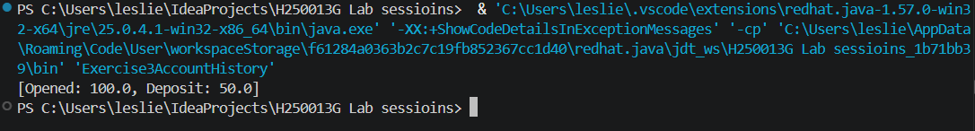Explanation: The getter returns an unmodifiable copy so callers cannot change the account’s internal history.

Exercise 4
Question: Create final ImmutablePerson with final fields and no setters; explain design.
Java source code:
final class ImmutablePerson {
private final String name;
private final int age;

ImmutablePerson(String name, int age) {
this.name = name;
this.age = age;
}

String getName() {
return name;
}

int getAge() {
return age;
}
}

public class Exercise4ImmutablePerson {
public static void main(String[] args) {
// Final fields and no setters keep this value unchanged.
ImmutablePerson person = new ImmutablePerson("Leslie Sarai", 21);
System.out.println(person.getName() + ", " + person.getAge());
}
}

Expected output (sample):
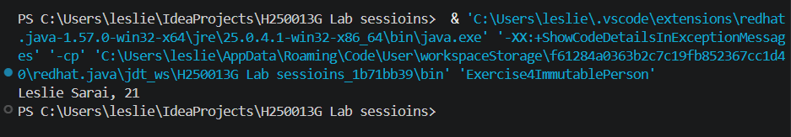Explanation: final prevents subclassing, final fields cannot be reassigned, and no setters prevent changes after construction.

Exercise 5
Question: Store kelvin internally, provide Celsius/Fahrenheit getters and reject below absolute zero.
Java source code:
class KelvinTemperature {
private final double kelvin;

KelvinTemperature(double kelvin) {
if (kelvin < 0) {
throw new IllegalArgumentException("Below absolute zero");
}
this.kelvin = kelvin;
}

double getCelsius() {
return kelvin - 273.15;
}

double getFahrenheit() {
return getCelsius() * 9 / 5 + 32;
}
}

public class Exercise5KelvinTemperature {
public static void main(String[] args) {
KelvinTemperature temperature = new KelvinTemperature(300);
// Both conversions use the stored Kelvin value.
System.out.printf("Celsius %.2f, Fahrenheit %.2f%n",
temperature.getCelsius(), temperature.getFahrenheit());
}
}

Expected output (sample):
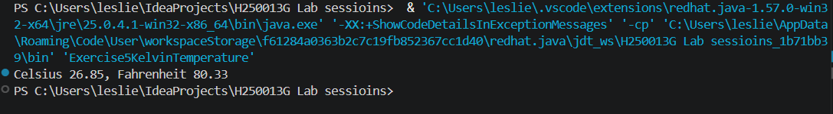Explanation: Kelvin is private implementation detail. Callers use the same getters even if internal storage changes later.

